CHAPTER 4

RESULTS AND DISCUSSION

## 4.1 INTRODUCTION

In this chapter, we present and discuss the results of the data analysis and the model evaluation for the predictive modelling of adsorption efficiency of nanocellulosic composite for the removal of cobalt II ion from waste water using Python. We also present and compare the results of the application of multiple kinetic models, such as Adams-Bohart, Thomas, Weibull, Wolborska, Yan, and Yoon-Nelson, to the experimental data and their errors for different adsorption conditions.

## 4.2 DATA ANALYSIS AND MODEL EVALUATION

The data analysis and model evaluation were performed using the methodology described in the previous chapter. The performance metrics of the three machine learning algorithms, namely: Ridge Regression, support vector regression (SVR), and Random Forest Regressor, are shown in Table 1.

|  |  |  |  |
| --- | --- | --- | --- |
| **Algorithm** | **R2** | **RMSE** | **MAE** |
| Ridge Regression | 0.8436 | 0.4052 | 0.276 |
| SVR | 0.3381 | 0.8334 | 0.6107 |
| Random Forest | 0.8096 | 0.447 | 0.2706 |

Table 4. 1: Performance metrics of the machine learning algorithms

As can be seen from Table 1, Ridge Regression model achieved the best performance among the three algorithms, with the highest R2 and very low RMSE and MAE values. This indicates that Ridge Regression model was able to capture the nonlinear and complex relationship between the input variables and the output variable, and to provide accurate and precise predictions of the adsorption efficiency. The Random Forest model also performed well, with slightly lower R2 and higher RMSE and MAE values than the Ridge Regression model. The SVR model had the lowest performance, with the lowest R2 and the highest RMSE and MAE values. This suggests that the SVR model was not able to account for the nonlinear and complex nature of the problem, and to fit the data well.

The plot of the actual vs. predicted values of the adsorption efficiency for the RIDGE REGRESSION model is shown in Figure 4.1.

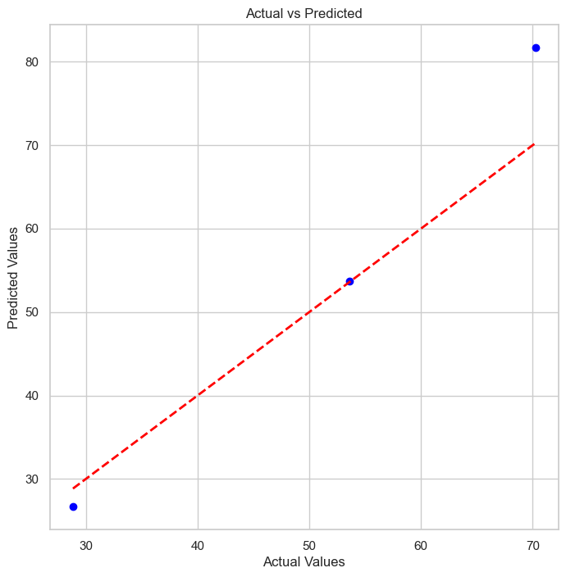

Figure 4. 1: Actual vs. predicted values of the adsorption efficiency for the Ridge Regression model

As can be seen from Figure 4.1, the Ridge Regression model was able to predict the adsorption efficiency with a high degree of accuracy, as most of the points were close to the 45-degree line, indicating a good agreement between the actual and the predicted values. The residual plot of the Ridge Regression model is shown in Figure 4.2.

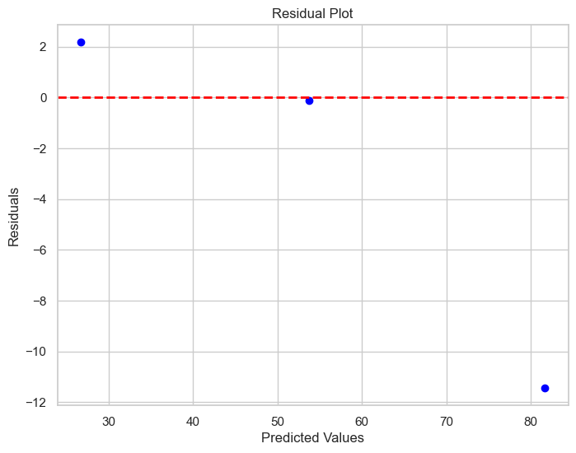

Figure 4. 2 Residual plot of the Ridge Regression model

As can be seen from Figure 4.2, the residuals of the Ridge Regression model were randomly distributed around zero, indicating that the model did not have any systematic bias or heteroscedasticity. The normal probability plot of the residuals of the RIDGE REGRESSION model is shown in Figure 4.3.

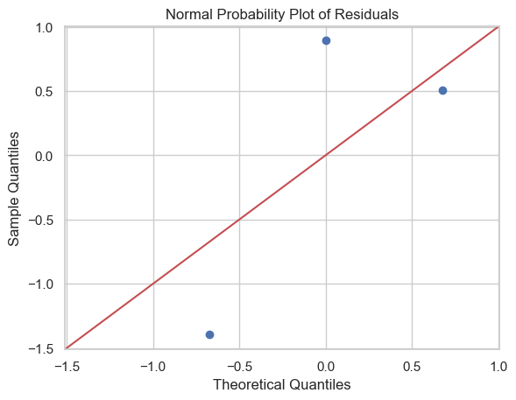

Figure 4. 3: Normal probability plot of the residuals of the Ridge Regression model

As can be seen from Figure 4.3, the residuals of the Ridge Regression model followed a normal distribution, as most of the points were close to the straight line, indicating that the model met the assumption of normality.

These results demonstrate that the Ridge Regression model was the best model for the predictive modelling of adsorption efficiency of nanocellulosic composite for the removal of cobalt II ion from waste water using Python, as it had the highest prediction accuracy and the lowest prediction error, and it satisfied the assumptions of linearity, homoscedasticity, and normality.

## 4.3 KINETIC MODELS AND THEIR ERRORS

The kinetic models are mathematical equations that describe the rate of adsorption of the adsorbate on the adsorbent as a function of time and other parameters. The kinetic models can provide information about the mechanism and the controlling factors of the adsorption process, as well as the adsorption capacity and the equilibrium time of the adsorbent. The kinetic models can also be used to compare the performance of different adsorbents and to optimize the adsorption conditions.

In this study, six kinetic models, namely Adams-Bohart, Thomas, Weibull, Wolborska, Yan, and Yoon-Nelson, were applied to the experimental data of the adsorption of cobalt II ion on the nanocellulosic composite. The equations and the parameters of the kinetic models are shown in Table 3.1.

### 4.3.1 THOMAS KINETIC MODEL

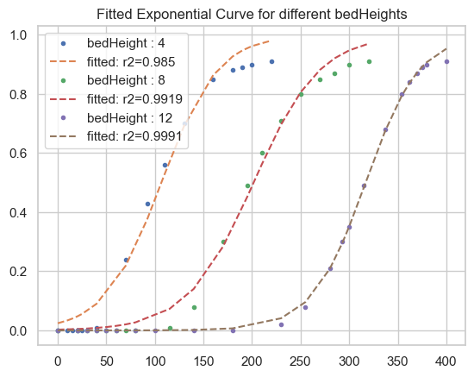

Figure 4. 4: The effect of bed heights on breakthrough curve at constant concentration of 100mg/L

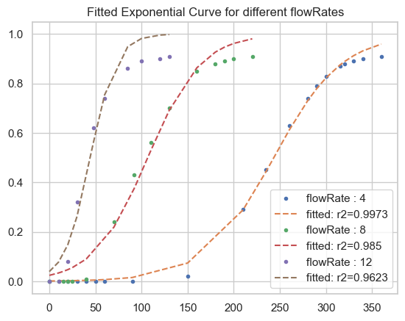

Figure 4. 5: Effect of flowrate on breakthrough curve on the adsorption of Co2 ion

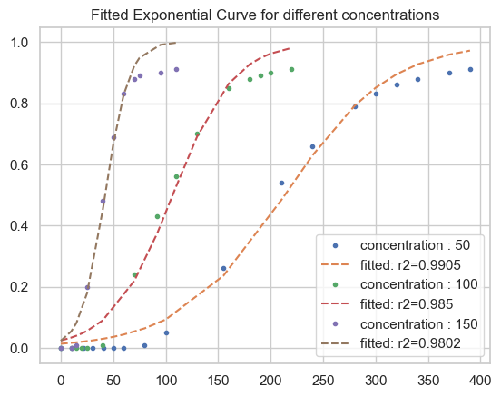

Figure 4. 6: Effect of Concentration on breakthrough time at constant bed height of 4cm and flow rate of 8mL/min

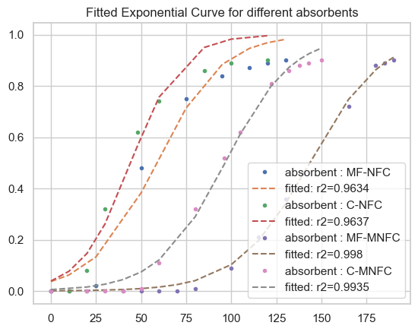

Figure 4. 7: Effect of absorbents on breakthrough time at constant flowrate, concentration and bed height

Thomas kinetic model is expressed as:

Ln = kTHq0 m -

Q

kTHC0 t

where 𝑘Th is the Thomas kinetic coefficient (mL/min mg), 𝑡 is the total flow time (min), and 𝑄 is the volumetric flow rate (mL/min). Adsorption capacity and mass of the adsorbent are denoted as 𝑞0 (mg/g) and 𝑚 (g). Plot of ln[(𝐶0/𝐶𝑡) − 1] versus 𝑡 gives the value of 𝑘Th and 𝑞0 (Swarup Biswas and Umesh Mishra, 2015).

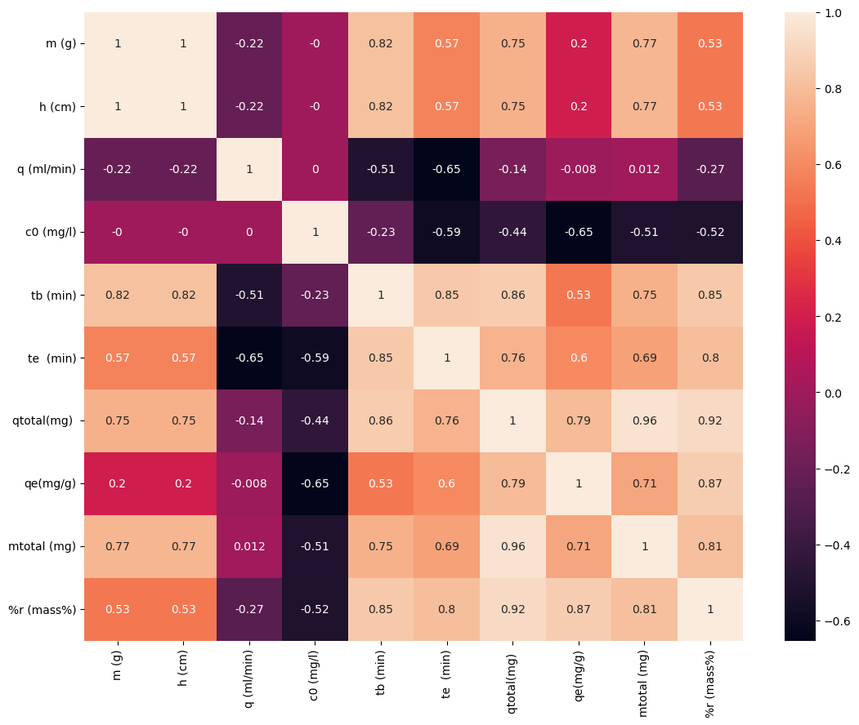

Figure 4. 8: Variables correlation plot

At constant influent concentration(Co) of 100mg/L and flow rate(Q) of 8ml/min as shown in figure 4.8 and confirmed in figure 4.4, 4.5, and 4.6 above, it is observed that breakthrough time is positively correlated for different bed heights and negatively correlated for different flow rate and concentration values. The same thing also applies to the R2 values as shown in the table below.

|  |  |  |  |  |
| --- | --- | --- | --- | --- |
| Condition | Parameters | | Constants | R2 value |
|  | K | q0 |  |  |
| Bed height: 4cm  Bed height: 8cm  Bed height: 12cm | 0.00035  0.00029  0.00036 | 21342.07  20161.6  21125.99 | Co = 100mg/L  Q = 8ml/min  M = 4g | 0.98497  0.99185  0.9991 |
| Flow rate: 4ml/min  Flow rate: 8ml/min  Flow rate: 12ml/min | 0.00027  0.00035  0.00072 | 24331.21  21342.07  13316.55 | Co = 100mg/L  B = 4cm  M = 4g | 0.99731  0.98497  0.96231 |
| Concentration: 50mg/L  Concentration: 100mg/L  Concentration: 150mg/L | 0.0004  0.00035  0.00059 | 21348.74  21342.07  12661.38 | B = 4cm  Q = 8ml/min  M = 4g | 0.99053  0.98497  0.98016 |
| Absorbent: MF-NFC  Absorbent: C-NFC  Absorbent: MF-MNFC  Absorbent: C-MNFC | 0.00056  0.00072  0.0005  0.00054 | 17572.5  13299.4  42994.87  28966.9 | Co = 100mg/L  B = 4cm  M = 4g  Q = 12ml/min | 0.96342  0.96374  0.99797  0.99346 |

Table 4. 2

However, for the model parameters, we can observe that the value of q0 decreases with increase in flow rate and concentration value, and on the other have the value of K increases with increase in flow rate. Overall we can also observe that r squared value ranges from 0.96 to 0.99 which indicates a good fitting of Thomas model for our breakthrough curve.

### 4.3.2 WEIBULL KINETIC MODEL

Weibull kinetic model is also applied to our experimental data to check for a perfect fit. It is expressed mathematically as:

= 1 – exp [ -]

Where c is the effluent concentration at any time t, c0 is the feed concentration, a > 0 is a rate parameter, and b > 0 is a shape parameter. The Weibull function generates S-shaped curves for b > 1. Its two unknown parameters, a and b, can be easily determined using a spreadsheet program with a built-in optimization routine. (Weibull, 1951)

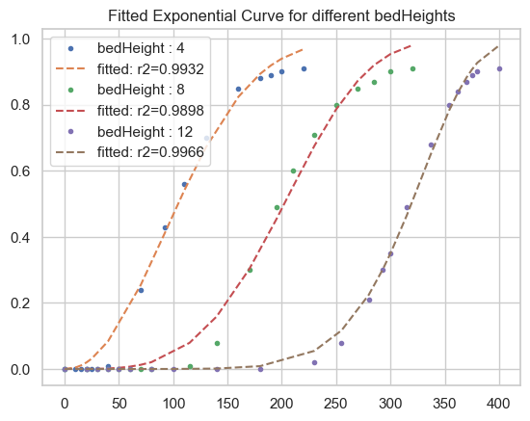

Figure 4. 9: Weibull model on bed heights against time

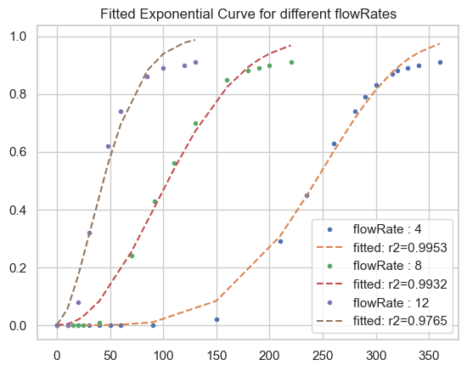

Figure 4. 10: Weibull model on flow rates against time

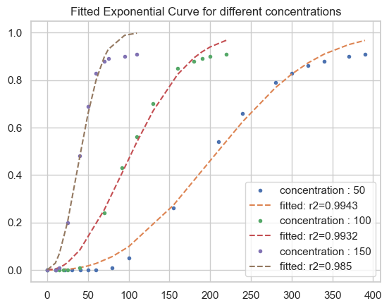

Figure 4. 11: Weibull model on Concentration against time

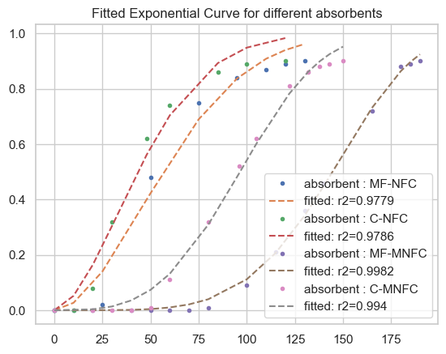

Figure 4. 12: Weibull model on absorbents against time

The details of the different model parameters, constants and conditions are shown in the table below

|  |  |  |  |  |
| --- | --- | --- | --- | --- |
| Condition | Parameters | | Constants | R2 value |
|  | ɑ | b |  |  |
| Bed height: 4cm  Bed height: 8cm  Bed height: 12cm | 123.844  222.879  334.973 | 2.156  3.774  7.645 | Co = 100mg/L  Q = 8ml/min  M = 4g | 0.9932  0.9898  0.9966 |
| Flow rate: 4ml/min  Flow rate: 8ml/min  Flow rate: 12ml/min | 265.428  123.844  54.209 | 4.261  2.156  1.681 | Co = 100mg/L  B = 4cm  M = 4g | 0.9953  0.9932  0.9765 |
| Concentration: 50mg/L  Concentration: 100mg/L  Concentration: 150mg/L | 241.665  123.844  48.491 | 2.572  2.156  2.241 | B = 4cm  Q = 8ml/min  M = 4g | 0.9943  0.9932  0.985 |
| Absorbent: MF-NFC  Absorbent: C-NFC  Absorbent: MF-MNFC  Absorbent: C-MNFC | 68.946  53.598  155.958  107.652 | 1.863  1.743  4.799  3.35 | Co = 100mg/L  B = 4cm  M = 4g  Q = 12ml/min | 0.9779  0.9786  0.9982  0.994 |

Table 4. 3

Weibull model show a stable and clear relationship between model parameters and different conditions. We can observe a positive relationship between bed height and both model parameters (ɑ and b) respectively, while on the other have we see a negative relationship between the model parameters and flow rate same also applies to concentration. However, we can observe a near perfect fit from Weibull model with r2 ranging from 0.97 to 0.99 which indicate a good fit.

### 4.3.3 YAN KINETIC MODEL

Yan model also known as Dose-Response model was also applied to our breakthrough data to check for a perfect fit. It is expressed mathematically as:

Where:

is the maximum uptake capacity (mg/g), a is an empirical parameter that decides the slope of the regression function and M is the dry weight of the sorbent (g).

The values of qo and a can be estimated by the non-linear fitting of Equation to the experimental data of the breakthrough curves. (Yan, et al., 2009).

The experimentation results are displayed in the images below for different conditions

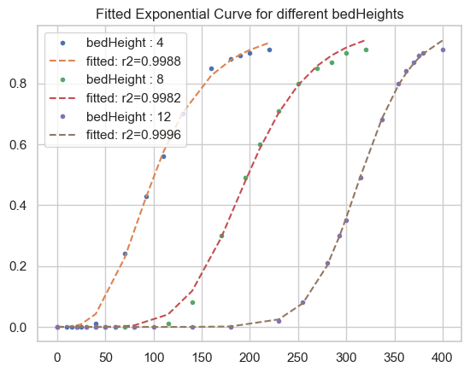

Figure 4. 13: Yan model fitting for bed heights

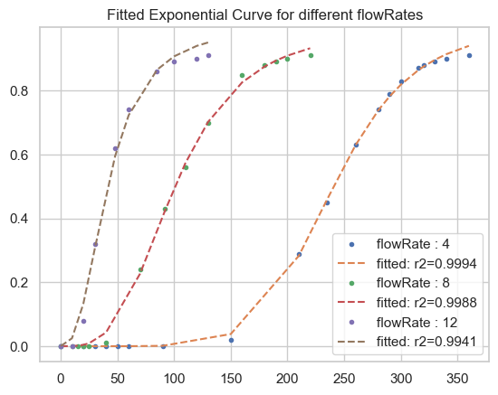

Figure 4. 14: Yan model fitting for flow rates

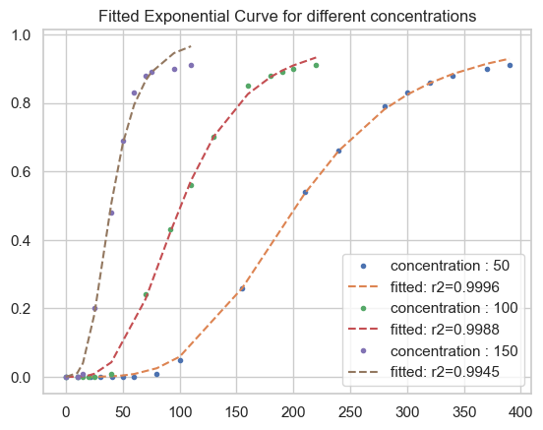

Figure 4. 15: Yan model fitting for concentration

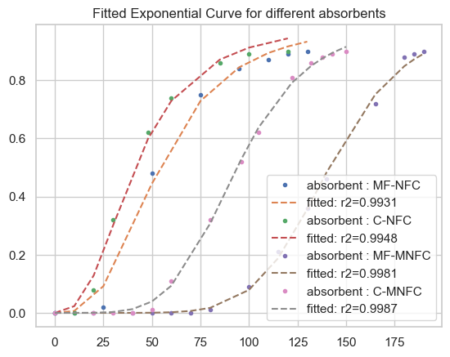

Figure 4. 16: Yan model fitting for absorbents

Yan model results and parameters are displayed in the table below

|  |  |  |  |  |
| --- | --- | --- | --- | --- |
| Condition | Parameters | | Constants | R2 value |
|  | q0 | ɑ |  |  |
| Bed height: 4cm  Bed height: 8cm  Bed height: 12cm | 20.153  19.811  21.027 | 3.366  5.795  11.628 | Co = 100mg/L  Q = 8ml/min  M = 4g | 0.9988  0.9982  0.9996 |
| Flow rate: 4ml/min  Flow rate: 8ml/min  Flow rate: 12ml/min | 24.063  20.153  12.411 | 6.834  3.366  2.583 | Co = 100mg/L  B = 4cm  M = 4g | 0.9994  0.9988  0.9941 |
| Concentration: 50mg/L  Concentration: 100mg/L  Concentration: 150mg/L | 20.253  20.153  11.891 | 3.928  3.366  3.262 | B = 4cm  Q = 8ml/min  M = 4g | 0.9996  0.9988  0.9945 |
| Absorbent: MF-NFC  Absorbent: C-NFC  Absorbent: MF-MNFC  Absorbent: C-MNFC | 16.162  12.379  42.383  28.168 | 2.986  2.644  7.109  5.077 | Co = 100mg/L  B = 4cm  M = 4g  Q = 12ml/min | 0.9931  0.9948  0.9981  0.9987 |

Table 4. 4

The results above show a clear and stable relationship between parameters and their conditions as earlier discovered in other models. Here, we can see a strong trend in the ɑ parameter based on different conditions. However, based on our result, we can see a near perfect fit on Yan model with a consistent R2 value of 0.99.

### 4.3.4 YOON-NELSON KINETIC MODEL

Yoon-Nelson model was also implemented on our dataset to test for best fit. It can be expressed mathematically as

Ln= kYN t - kYN Ʈ,

where kYN stands for the Yoon-Nelson rate constant (min-1), t represents the processing time (min) and Ʈ refers to the length of time (min) necessary for the attainment of 50% initial adsorbent concentration in the effluent stream. The product of these two variables is constant for a particular adsorbent-adsorbate system and independent of both the flow rate and the initial adsorbate concentration (Franca and Oliveira, 2010). If the experimental data describes the model accurately, then kYN and Ʈ can be evaluated from the gradient and the intercept of the graph of Ln () versus t at different bed masses or heights, flow rates and initial concentrations.

Results are displayed in the images below.

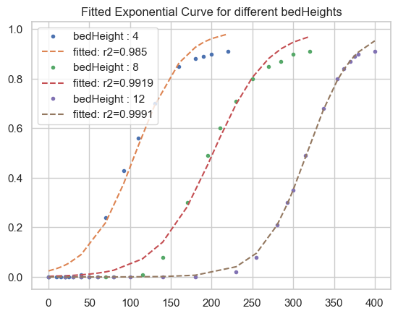

Figure 4. 17: Yoon Nelson model fitting for bed heights

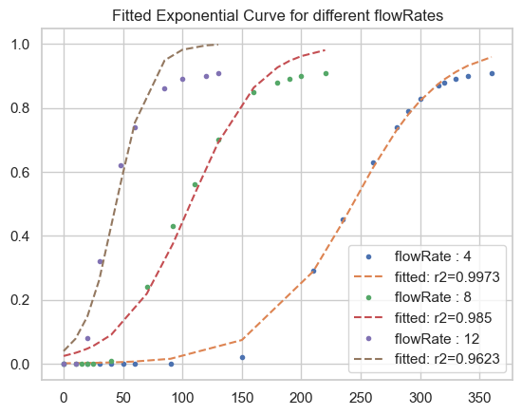

Figure 4. 18: Yoon Nelson model fitting for different flow rates

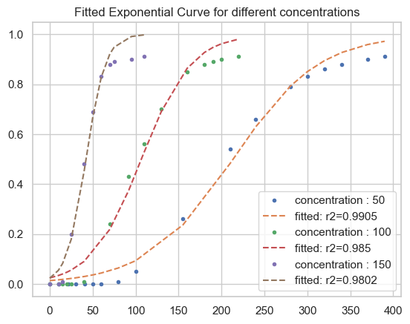

Figure 4. 19: Yoon Nelson model fitting for different concentrations

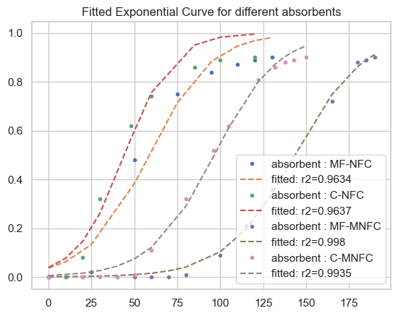

Figure 4. 20: Yoon Nelson model fitting for different absorbents

Yoon Nelson model results and parameters are shown in the table below

|  |  |  |  |  |
| --- | --- | --- | --- | --- |
| Condition | Parameters | | Constants | R2 value |
|  | KYN | Ʈ |  |  |
| Bed height: 4cm  Bed height: 8cm  Bed height: 12cm | 0.035  0.029  0.036 | 106.71  201.616  316.89 | Co = 100mg/L  Q = 8ml/min  M = 4g | 0.985  0.9919  0.9991 |
| Flow rate: 4ml/min  Flow rate: 8ml/min  Flow rate: 12ml/min | 0.027  0.035  0.072 | 243.312  106.71  44.388 | Co = 100mg/L  B = 4cm  M = 4g | 0.9973  0.985  0.9623 |
| Concentration: 50mg/L  Concentration: 100mg/L  Concentration: 150mg/L | 0.02  0.035  0.089 | 213.487  106.71  42.205 | B = 4cm  Q = 8ml/min  M = 4g | 0.9905  0.985  0.9802 |
| Absorbent: MF-NFC  Absorbent: C-NFC  Absorbent: MF-MNFC  Absorbent: C-MNFC | 0.056  0.072  0.05  0.054 | 58.575  44.331  143.316  96.556 | Co = 100mg/L  B = 4cm  M = 4g  Q = 12ml/min | 0.9634  0.9637  0.998  0.9935 |

Table 4. 5

From the table above we can observe a stable correlation between Ʈ and adsorption conditions, and also R2 values. The value of KYN also increases as flow rate increases. Overall R2 value ranges from 0.96 to 0.99 which is a good fit for our data and almost identical to Thomas Kinetic Model.

### 4.3.5 ADAMS BOHART KINETIC MODEL

Our experimental data was also implemented on Adams Bohart kinetic model, to check how well it fits our experimental data. It can be mathematically expressed as

Ln = kBA C0t - kBAzN0

V0

where C0 is equivalent to inlet or influent concentration at time t = 0 (mgL-1), Ct effluent concentration at time t = t (mgL-1), kBA corresponds to the kinetic rate constant for the Bohart-Adams’ model (Lmg-1min-1), z is length of the column bed (cm) while N0 represent the adsorbent saturation concentration (mgL-1) and v0 is the linear velocity influent liquid (cm min-1) which is the quotient of the volumetric flow rate and the cross sectional area of the bed. Moreover, bed height can be replaced by the adsorbent mass (g) since the values of the breakthrough time determined for various bed heights can be incorporated into the BDST model (Patel, 2019).

Images from the fitted curve of our experimental data are displayed below.

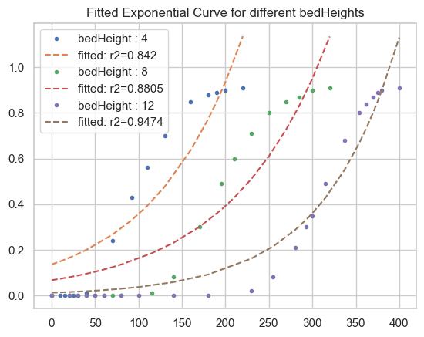

Figure 4. 21: Adams Bohart fitted curve for different bed heights

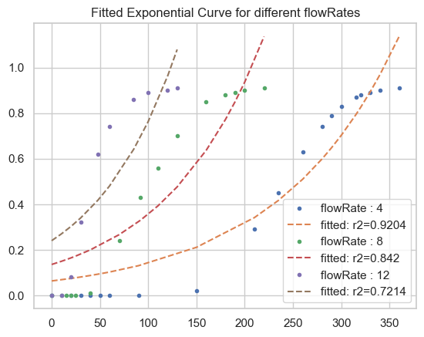

Figure 4. 22: Adams Bohart model for different flow rates

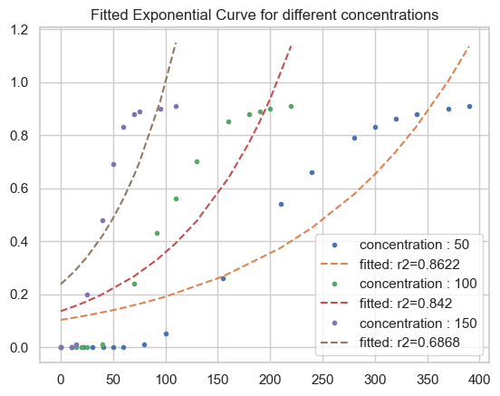

Figure 4. 23: Adams Bohart model for different concentration

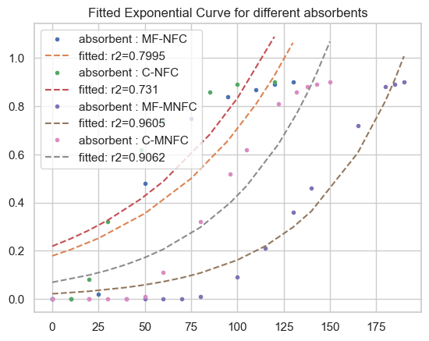

Figure 4. 24: Adams Bohart model for different absorbents

Adams Bohart model parameters at different conditions are displayed in the table below

|  |  |  |  |  |
| --- | --- | --- | --- | --- |
| Condition | Parameters | | Constants | R2 value |
|  | kBA | N0 |  |  |
| Bed height: 4cm  Bed height: 8cm  Bed height: 12cm | 9.7e-05  8.9e-05  0.000114 | 1493.0  1103.75  936.8 | Co = 100mg/L  Q = 8ml/min  M = 4g | 0.842  0.8805  0.9474 |
| Flow rate: 4ml/min  Flow rate: 8ml/min  Flow rate: 12ml/min | 8e-05  9.7e-05  0.000116 | 1241.684  1493.0  1336.395 | Co = 100mg/L  B = 4cm  M = 4g | 0.9204  0.842  0.7214 |
| Concentration: 50mg/L  Concentration: 100mg/L  Concentration: 150mg/L | 0.000123  9.7e-05  9.6e-05 | 1333.719  1493.0  1086.542 | B = 4cm  Q = 8ml/min  M = 4g | 0.8622  0.842  0.6868 |
| Absorbent: MF-NFC  Absorbent: C-NFC  Absorbent: MF-MNFC  Absorbent: C-MNFC | 0.000137  0.000134  0.000204  0.000183 | 1359.637  1230.814  2053.726  1585.302 | Co = 100mg/L  B = 4cm  M = 4g  Q = 12ml/min | 0.7995  0.731  0.9605  0.9062 |

Table 4. 6

We can observe a poor fit from adams bohart model with the R2 ranging from 0.68 to 0.94. Which is an indication that adams bohart model does not perform very well on our experimental data in fitting our experimental breakthrough curve.

### 4.3.6 WOLBORSKA KINETIC MODEL

Regardless of the fact that Wolborska model is somewhat identical to Adams- Bohart model, We try to fit our experimental data on Wolborska kinetic model to examine its performance on our experimental data. It can be expressed mathematically as:

Ln = βα  - βα

t

N0

V0

where βα represents the kinetic coefficient of the external mass transfer (min-1) while ν0 stands for linear velocity (cm min-1) and N0 is equivalent to saturation concentration or adsorption capacity (mgL-1). The parameters of Wolborska`s model viz; βα and N0, can be evaluated from the linear dependence of Ln () versus time. However, if the value of the ratio βα /N0 is equivalent to then the Wolborska solution will be similar to Bohart-Adams solution (Madan et al, 2019).

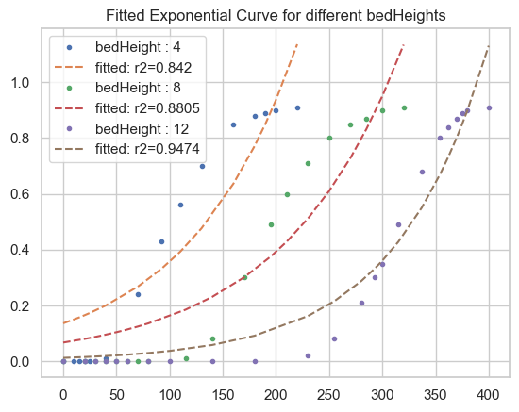

Figure 4. 25: Wolborska model breakthrough curve for different bed heights

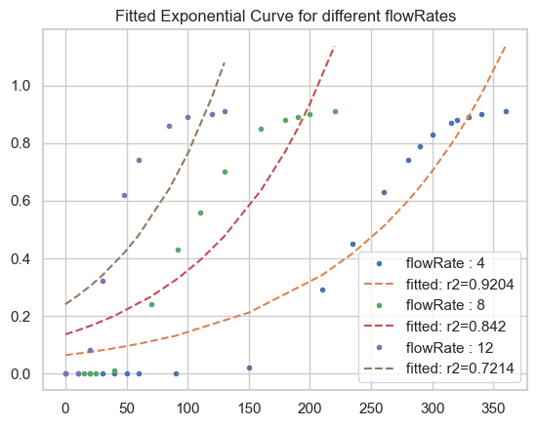

Figure 4. 26: Wolborska model breakthrough curve for different flow rates

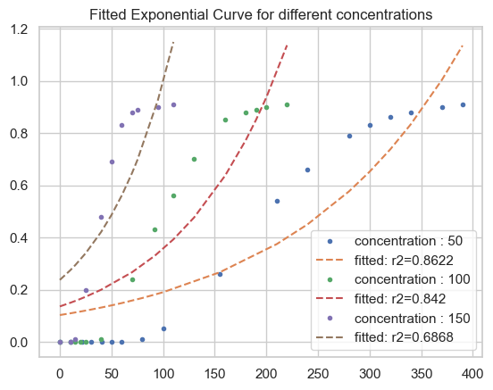

Figure 4. 27: Wolborska model breakthrough curve for different concentration

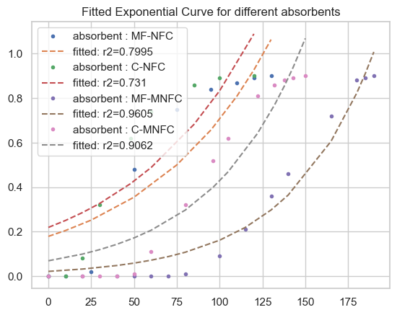

Figure 4. 28: Wolborska model breakthrough curve for different absorbents

Wolborska model parameters at different conditions are also displayed in the table below

|  |  |  |  |  |
| --- | --- | --- | --- | --- |
| Condition | Parameters | | Constants | R2 value |
|  | βα | N0 |  |  |
| Bed height: 4cm  Bed height: 8cm  Bed height: 12cm | 0.144  0.098  0.107 | 1493.001  1103.751  936.8 | Co = 100mg/L  Q = 8ml/min  M = 4g | 0.842  0.8805  0.9474 |
| Flow rate: 4ml/min  Flow rate: 8ml/min  Flow rate: 12ml/min | 0.1  0.144  0.155 | 1241.685  1493.001  1336.387 | Co = 100mg/L  B = 4cm  M = 4g | 0.9204  0.842  0.7214 |
| Concentration: 50mg/L  Concentration: 100mg/L  Concentration: 150mg/L | 0.164  0.144  0.104 | 1333.721  1493.001  1086.536 | B = 4cm  Q = 8ml/min  M = 4g | 0.8622  0.842  0.6868 |
| Absorbent: MF-NFC  Absorbent: C-NFC  Absorbent: MF-MNFC  Absorbent: C-MNFC | 0.187  0.165  0.418  0.29 | 1359.633  1230.819  2053.726  1585.304 | Co = 100mg/L  B = 4cm  M = 4g  Q = 12ml/min | 0.7995  0.731  0.9605  0.9062 |

Table 4. 7

From the table above, we can observe that R2 value for Wolborska and Adams-Bohart kinetic model are identical, but different parameters values. However, we can also observe a poor fit from Wolborska model.

## 4.4 ERROR FUNCTION ANALYSIS

Depending on the R2 value for different models, Yan model seem to be the best fitted model for our analysis. However, we can only be fully sure of this when we examine the error functions of all the model and make comparisons to pick out the optimal kinetic model.

### 4.4.1 THOMAS KINETIC MODEL ERRORS

|  |  |  |  |  |  |  |  |  |  |  |  |
| --- | --- | --- | --- | --- | --- | --- | --- | --- | --- | --- | --- |
| absorbent | b | Q | Co | R2 | Marquardt | SSE | SAE | Hybrid | ARE | MSE | NLCS |
| C-NCF | 4 | 8 | 100 | 0.985 | 2.153 | 0.034 | 0.647 | 5.156 | 0.597 | 0.002 | 0.005 |
| C-NCF | 8 | 8 | 100 | 0.992 | 1.602 | 0.022 | 0.523 | 2.681 | 0.389 | 0.001 | 0.004 |
| C-NCF | 12 | 8 | 100 | 0.999 | 1.033 | 0.003 | 0.131 | 0.134 | 0.225 | 0 | 0.002 |
| C-NCF | 4 | 4 | 100 | 0.997 | 1.312 | 0.008 | 0.264 | 0.892 | 0.318 | 0 | 0.003 |
| C-NCF | 4 | 8 | 100 | 0.985 | 2.153 | 0.034 | 0.647 | 5.156 | 0.597 | 0.002 | 0.005 |
| C-NCF | 4 | 12 | 100 | 0.962 | 3.414 | 0.052 | 0.677 | 1.377 | 1.207 | 0.005 | 0.008 |
| C-NCF | 4 | 8 | 50 | 0.991 | 1.701 | 0.026 | 0.619 | 2.202 | 0.425 | 0.001 | 0.004 |
| C-NCF | 4 | 8 | 100 | 0.985 | 2.153 | 0.034 | 0.647 | 5.156 | 0.597 | 0.002 | 0.005 |
| C-NCF | 4 | 8 | 150 | 0.98 | 3.207 | 0.032 | 0.503 | 6.118 | 1.069 | 0.003 | 0.008 |
| MF-MNFC | 4 | 12 | 100 | 0.998 | 0.358 | 0.004 | 0.195 | 0.759 | 0.099 | 0 | 0 |
| C-MNFC | 4 | 12 | 100 | 0.993 | 1.53 | 0.013 | 0.363 | 3.525 | 0.442 | 0.001 | 0.003 |
| MF-NFC | 4 | 12 | 100 | 0.963 | 3.432 | 0.049 | 0.626 | 9.803 | 1.297 | 0.005 | 0.007 |
| C-NFC | 4 | 12 | 100 | 0.964 | 4.025 | 0.044 | 0.59 | 1.433 | 1.521 | 0.005 | 0.01 |

Table 4. 8

## YOON NELSON KINETIC MODEL ERRORS

|  |  |  |  |  |  |  |  |  |  |  |  |
| --- | --- | --- | --- | --- | --- | --- | --- | --- | --- | --- | --- |
| absorbent | b | Q | Co | R2 | Marquardt | SSE | SAE | Hybrid | ARE | MSE | NLCS |
| C-NCF | 4 | 8 | 100 | 0.985 | 2.153 | 0.034 | 0.647 | 5.156 | 0.597 | 0.002 | 0.005 |
| C-NCF | 8 | 8 | 100 | 0.992 | 1.602 | 0.022 | 0.523 | 2.681 | 0.389 | 0.001 | 0.004 |
| C-NCF | 12 | 8 | 100 | 0.999 | 1.033 | 0.003 | 0.131 | 0.134 | 0.225 | 0 | 0.002 |
| C-NCF | 4 | 4 | 100 | 0.997 | 1.312 | 0.008 | 0.264 | 0.892 | 0.318 | 0 | 0.003 |
| C-NCF | 4 | 8 | 100 | 0.985 | 2.153 | 0.034 | 0.647 | 5.156 | 0.597 | 0.002 | 0.005 |
| C-NCF | 4 | 12 | 100 | 0.962 | 3.414 | 0.052 | 0.677 | 1.377 | 1.207 | 0.005 | 0.008 |
| C-NCF | 4 | 8 | 50 | 0.991 | 1.701 | 0.026 | 0.619 | 2.202 | 0.425 | 0.001 | 0.004 |
| C-NCF | 4 | 8 | 100 | 0.985 | 2.153 | 0.034 | 0.647 | 5.156 | 0.597 | 0.002 | 0.005 |
| C-NCF | 4 | 8 | 150 | 0.98 | 3.207 | 0.032 | 0.503 | 6.118 | 1.069 | 0.003 | 0.008 |
| MF-MNFC | 4 | 12 | 100 | 0.998 | 0.358 | 0.004 | 0.195 | 0.759 | 0.099 | 0 | 0 |
| C-MNFC | 4 | 12 | 100 | 0.993 | 1.53 | 0.013 | 0.363 | 3.525 | 0.442 | 0.001 | 0.003 |
| MF-NFC | 4 | 12 | 100 | 0.963 | 3.432 | 0.049 | 0.626 | 9.803 | 1.297 | 0.005 | 0.007 |
| C-NFC | 4 | 12 | 100 | 0.964 | 4.025 | 0.044 | 0.59 | 1.433 | 1.521 | 0.005 | 0.01 |

Table 4. 9

### 4.4.2 WEIBULL KINECTIC MODEL ERRORS

|  |  |  |  |  |  |  |  |  |  |  |  |
| --- | --- | --- | --- | --- | --- | --- | --- | --- | --- | --- | --- |
| absorbent | b | Q | Co | R2 | Marquardt | SSE | SAE | Hybrid | ARE | MSE | NLCS |
| C-NCF | 4 | 8 | 100 | 0.993 | 1.777 | 0.016 | 0.39 | 4.27 | 0.493 | 0.001 | 0.004 |
| C-NCF | 8 | 8 | 100 | 0.99 | 1.867 | 0.028 | 0.527 | 3.382 | 0.453 | 0.001 | 0.005 |
| C-NCF | 12 | 8 | 100 | 0.997 | 1.664 | 0.011 | 0.301 | 0.421 | 0.363 | 0 | 0.005 |
| C-NCF | 4 | 4 | 100 | 0.995 | 1.715 | 0.014 | 0.344 | 1.282 | 0.416 | 0.001 | 0.005 |
| C-NCF | 4 | 8 | 100 | 0.993 | 1.777 | 0.016 | 0.39 | 4.27 | 0.493 | 0.001 | 0.004 |
| C-NCF | 4 | 12 | 100 | 0.977 | 2.996 | 0.032 | 0.491 | 1.607 | 1.059 | 0.003 | 0.007 |
| C-NCF | 4 | 8 | 50 | 0.994 | 1.578 | 0.016 | 0.419 | 1.73 | 0.394 | 0.001 | 0.004 |
| C-NCF | 4 | 8 | 100 | 0.993 | 1.777 | 0.016 | 0.39 | 4.27 | 0.493 | 0.001 | 0.004 |
| C-NCF | 4 | 8 | 150 | 0.985 | 3.227 | 0.024 | 0.39 | 4.192 | 1.076 | 0.002 | 0.009 |
| MF-MNFC | 4 | 12 | 100 | 0.998 | 0.745 | 0.003 | 0.18 | 0.742 | 0.207 | 0 | 0.001 |
| C-MNFC | 4 | 12 | 100 | 0.994 | 1.671 | 0.012 | 0.331 | 3.486 | 0.482 | 0.001 | 0.003 |
| MF-NFC | 4 | 12 | 100 | 0.978 | 2.588 | 0.03 | 0.417 | 10.605 | 0.978 | 0.003 | 0.004 |
| C-NFC | 4 | 12 | 100 | 0.979 | 3.485 | 0.026 | 0.42 | 1.563 | 1.317 | 0.003 | 0.008 |

Table 4. 10

### 4.4.3 YAN KINETIC MODEL ERRORS

|  |  |  |  |  |  |  |  |  |  |  |  |
| --- | --- | --- | --- | --- | --- | --- | --- | --- | --- | --- | --- |
| absorbent | b | Q | Co | R2 | Marquardt | SSE | SAE | Hybrid | ARE | MSE | NLCS |
| C-NCF | 4 | 8 | 100 | 0.9988 | 0.6899 | 0.0028 | 0.1474 | 0.8426 | 0.1913 | 0.0002 | 0.0006 |
| C-NCF | 8 | 8 | 100 | 0.9982 | 0.8401 | 0.0048 | 0.2058 | 0.6897 | 0.2038 | 0.0003 | 0.0011 |
| C-NCF | 12 | 8 | 100 | 0.9996 | 0.7345 | 0.0014 | 0.0997 | 0.0155 | 0.1603 | 0.0001 | 0.001 |
| C-NCF | 4 | 4 | 100 | 0.9994 | 0.802 | 0.0019 | 0.1208 | 0.1075 | 0.1945 | 0.0001 | 0.001 |
| C-NCF | 4 | 8 | 100 | 0.9988 | 0.6899 | 0.0028 | 0.1474 | 0.8426 | 0.1913 | 0.0002 | 0.0006 |
| C-NCF | 4 | 12 | 100 | 0.9941 | 1.578 | 0.0081 | 0.239 | 0.5112 | 0.5579 | 0.0008 | 0.0018 |
| C-NCF | 4 | 8 | 50 | 0.9996 | 0.5266 | 0.0011 | 0.1005 | 0.1625 | 0.1316 | 0.0001 | 0.0004 |
| C-NCF | 4 | 8 | 100 | 0.9988 | 0.6899 | 0.0028 | 0.1474 | 0.8426 | 0.1913 | 0.0002 | 0.0006 |
| C-NCF | 4 | 8 | 150 | 0.9945 | 2.031 | 0.0088 | 0.2486 | 1.1401 | 0.677 | 0.0008 | 0.0034 |
| MF-MNFC | 4 | 12 | 100 | 0.9981 | 0.2609 | 0.0037 | 0.1668 | 0.1007 | 0.0724 | 0.0002 | 0.0001 |
| C-MNFC | 4 | 12 | 100 | 0.9987 | 0.4871 | 0.0026 | 0.1548 | 0.748 | 0.1406 | 0.0002 | 0.0003 |
| MF-NFC | 4 | 12 | 100 | 0.9931 | 1.378 | 0.0093 | 0.2227 | 3.7569 | 0.5208 | 0.001 | 0.0012 |
| C-NFC | 4 | 12 | 100 | 0.9948 | 1.8438 | 0.0064 | 0.2 | 0.4881 | 0.6969 | 0.0007 | 0.0021 |

Table 4. 11

### 4.4.4 ADAMS-BOHART KINETIC MODEL ERRORS

|  |  |  |  |  |  |  |  |  |  |  |  |
| --- | --- | --- | --- | --- | --- | --- | --- | --- | --- | --- | --- |
| absorbent | b | Q | Co | R2 | Marquardt | SSE | SAE | Hybrid | ARE | MSE | NLCS |
| C-NCF | 4 | 8 | 100 | 0.842 | 6.896 | 0.358 | 2.111 | 29.756 | 1.913 | 0.024 | 0.056 |
| C-NCF | 8 | 8 | 100 | 0.88 | 5.989 | 0.325 | 2.239 | 21.059 | 1.453 | 0.017 | 0.055 |
| C-NCF | 12 | 8 | 100 | 0.947 | 5.3 | 0.166 | 1.477 | 6.632 | 1.157 | 0.007 | 0.054 |
| C-NCF | 4 | 4 | 100 | 0.92 | 6.062 | 0.236 | 1.87 | 11.775 | 1.47 | 0.012 | 0.057 |
| C-NCF | 4 | 8 | 100 | 0.842 | 6.896 | 0.358 | 2.111 | 29.756 | 1.913 | 0.024 | 0.056 |
| C-NCF | 4 | 12 | 100 | 0.721 | 6.581 | 0.385 | 1.789 | 11.078 | 2.327 | 0.038 | 0.032 |
| C-NCF | 4 | 8 | 50 | 0.862 | 6.185 | 0.382 | 2.442 | 19.922 | 1.546 | 0.021 | 0.056 |
| C-NCF | 4 | 8 | 100 | 0.842 | 6.896 | 0.358 | 2.111 | 29.756 | 1.913 | 0.024 | 0.056 |
| C-NCF | 4 | 8 | 150 | 0.687 | 8.751 | 0.499 | 2.16 | 94.324 | 2.917 | 0.045 | 0.063 |
| MF-MNFC | 4 | 12 | 100 | 0.961 | 3.316 | 0.076 | 0.954 | 8.236 | 0.92 | 0.005 | 0.013 |
| C-MNFC | 4 | 12 | 100 | 0.906 | 5.405 | 0.191 | 1.485 | 23.683 | 1.56 | 0.014 | 0.032 |
| MF-NFC | 4 | 12 | 100 | 0.799 | 6.851 | 0.271 | 1.435 | 41.052 | 2.589 | 0.03 | 0.03 |
| C-NFC | 4 | 12 | 100 | 0.731 | 7.925 | 0.329 | 1.561 | 10.898 | 2.995 | 0.037 | 0.04 |

Table 4. 12

### 4.4.5 WOLBORSKA KINETIC MODEL ERRORS

|  |  |  |  |  |  |  |  |  |  |  |  |
| --- | --- | --- | --- | --- | --- | --- | --- | --- | --- | --- | --- |
| absorbent | b | Q | Co | R2 | Marquardt | SSE | SAE | Hybrid | ARE | MSE | NLCS |
| C-NCF | 4 | 8 | 100 | 0.842 | 6.896 | 0.358 | 2.111 | 29.757 | 1.913 | 0.024 | 0.056 |
| C-NCF | 8 | 8 | 100 | 0.88 | 5.989 | 0.325 | 2.239 | 21.059 | 1.453 | 0.017 | 0.055 |
| C-NCF | 12 | 8 | 100 | 0.947 | 5.3 | 0.166 | 1.477 | 6.632 | 1.157 | 0.007 | 0.054 |
| C-NCF | 4 | 4 | 100 | 0.92 | 6.062 | 0.236 | 1.87 | 11.775 | 1.47 | 0.012 | 0.057 |
| C-NCF | 4 | 8 | 100 | 0.842 | 6.896 | 0.358 | 2.111 | 29.757 | 1.913 | 0.024 | 0.056 |
| C-NCF | 4 | 12 | 100 | 0.721 | 6.581 | 0.385 | 1.789 | 11.078 | 2.327 | 0.038 | 0.032 |
| C-NCF | 4 | 8 | 50 | 0.862 | 6.184 | 0.382 | 2.442 | 19.922 | 1.546 | 0.021 | 0.056 |
| C-NCF | 4 | 8 | 100 | 0.842 | 6.896 | 0.358 | 2.111 | 29.757 | 1.913 | 0.024 | 0.056 |
| C-NCF | 4 | 8 | 150 | 0.687 | 8.751 | 0.499 | 2.16 | 94.319 | 2.917 | 0.045 | 0.063 |
| MF-MNFC | 4 | 12 | 100 | 0.961 | 3.316 | 0.076 | 0.954 | 8.236 | 0.92 | 0.005 | 0.013 |
| C-MNFC | 4 | 12 | 100 | 0.906 | 5.405 | 0.191 | 1.485 | 23.684 | 1.56 | 0.014 | 0.032 |
| MF-NFC | 4 | 12 | 100 | 0.799 | 6.851 | 0.271 | 1.435 | 41.05 | 2.589 | 0.03 | 0.03 |
| C-NFC | 4 | 12 | 100 | 0.731 | 7.925 | 0.329 | 1.561 | 10.899 | 2.995 | 0.037 | 0.04 |

Table 4. 13

## 4.5 CONCLUSION

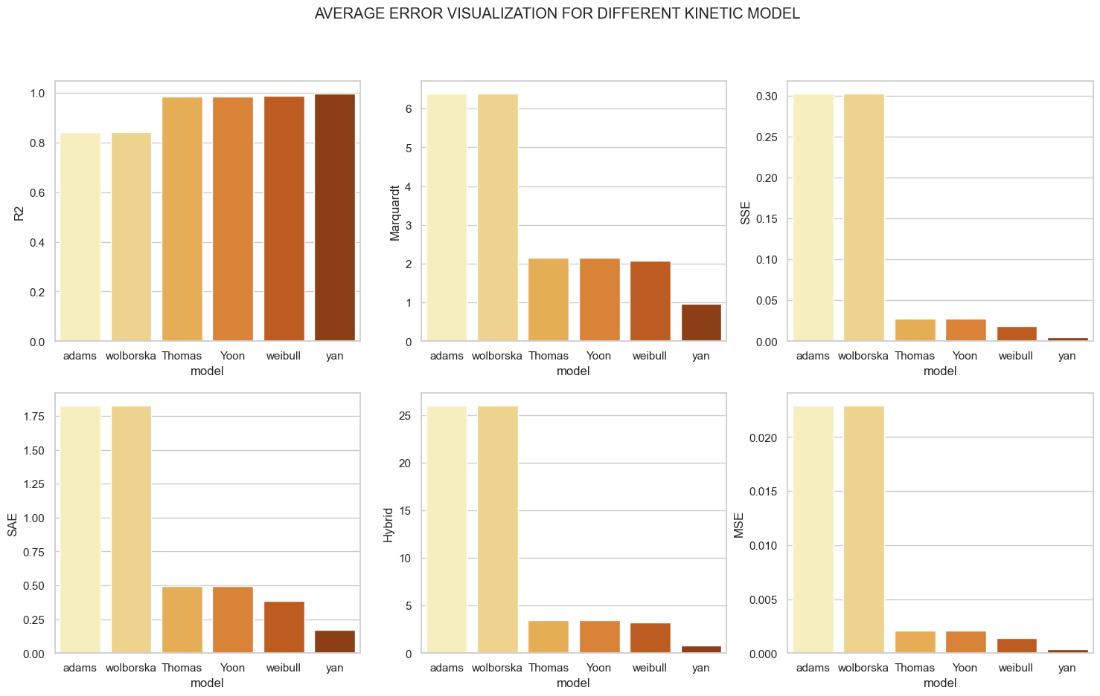

Figure 4. 29: Average error display, for all models used in the research

In conclusion to the above analysis, the best fitting model is selected by examining the model with the highest R2 value and with very small MSE, SSE, Hybrid, Marquardt, and SAE values. The only outcome that aligns with our specified criteria for selecting the perfect fitted model is the result from Yan Kinetic Model. The results clearly show that Yan Kinetic Model is the perfect model for fitting and observing the adsorption behavior for the removal of Cobalt II ion from waste water.

However, based on the results displayed above, we can also observe that models like Thomas and Yoon-Nelson kinetic models produce identical results, same as Adams-Bohart and Wolborska kinetic models which were the models that performed poorly in predicting concentration of adsorbate on the adsorbent (qexp).